Shrinkage correlation: AUDUSD and NZDUSD
Method 08 / eight-major panel / delta = 0.2 and Ledoit-Wolf / Alpari D1 full available history

Study setup
Logical pair: AUDUSD , NZDUSD
Broker symbols: AUDUSD_i , NZDUSD_i
Snapshot: 2026-11-03_majors_alpari_D1
Timeframe: D1
Common eight-major panel window: 1999-01-06 to 2026-11-02 (UTC bar dates)
Panel matched return count n: 7127
Dropped unfinished last bar dated 2026-11-03 UTC after a tick-volume check against the prior complete day.
Fixed shrinkage: delta=0.2, mu=3.9170889e-05 (mean of diag(S))
Ledoit-Wolf estimated delta: 0.0042157642
Panel symbols: EURUSD, GBPUSD, AUDUSD, NZDUSD, USDJPY, USDCHF, USDCAD, EURGBP
Complete matched rows (Excel): AUDUSD-NZDUSD_Shrinkage_D1.xlsx
Complete matched rows (HTML table): AUDUSD-NZDUSD_Shrinkage_D1_data.html

Method carried forward
Shrinkage blends the sample covariance matrix S of matched daily log returns of close, ln(close_t / close_t-1), toward a simple target, then converts the shrunk covariance into correlations. Quotes are not inverted. This experiment builds one common calendar across all eight majors, forms S with the unbiased n-1 divisor, then reports two shrinkage specs: fixed delta = 0.2 with mu equal to the average sample variance (mu * I target), and sklearn Ledoit-Wolf with its estimated delta. Pair reports pull rho_ij from those panel matrices. Same-panel Pearson r is a side check only. Shrinkage improves conditioning; it is not a cause, not a lead, and not a trading signal.

Results
pearson_r | rho_02 | rho_LW | rho_02_minus_r | rho_LW_minus_r | delta_LW
0.828775 | 0.708642 | 0.826403 | -0.120133 | -0.002372 | 0.00421576

Conclusion
Over the common 7127-day eight-major panel for AUDUSD and NZDUSD (broker quote directions unchanged), fixed-delta shrinkage correlation at delta=0.2 is 0.7086 (positive, strong linear link in this sample). Ledoit-Wolf rho is 0.8264 with estimated delta=0.004216. Same-panel Pearson r is 0.8288 (rho_02 minus r = -0.1201; rho_LW minus r = -0.0024). This does not establish cause, lead-lag, or a lasting trading rule.

Charts
Daily closes
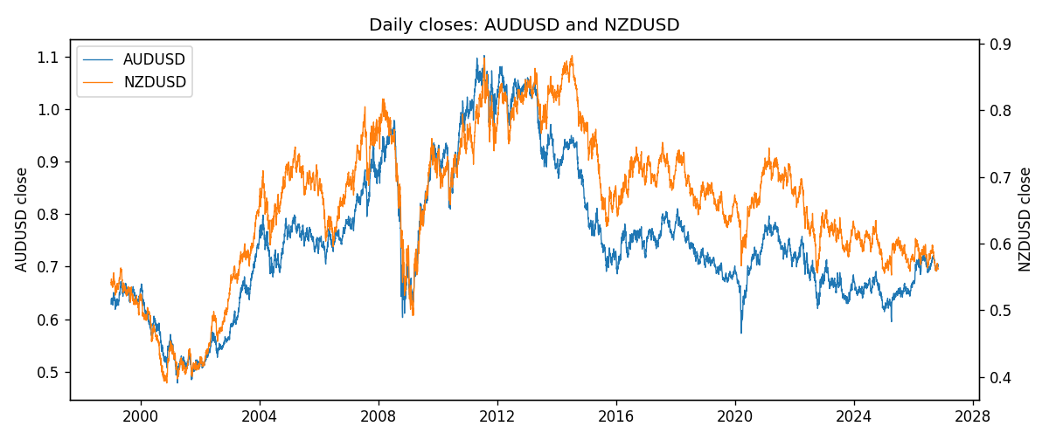
Daily log returns
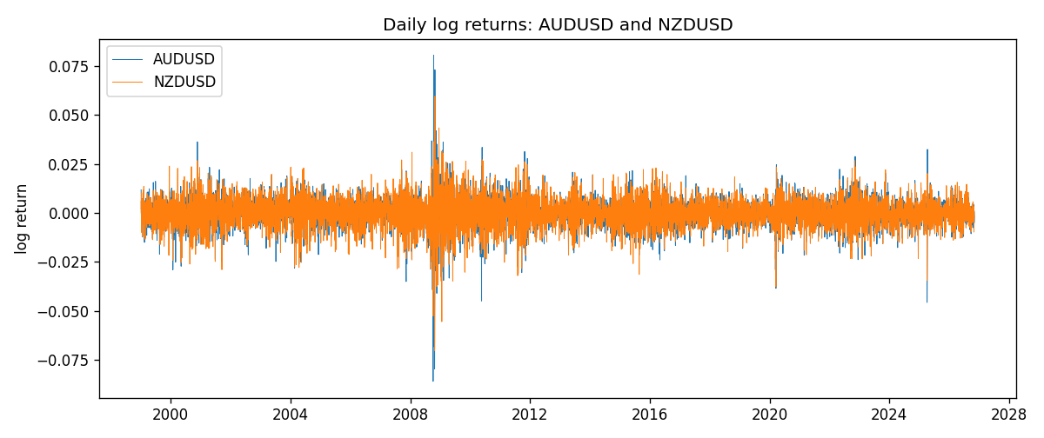
Log-return scatter
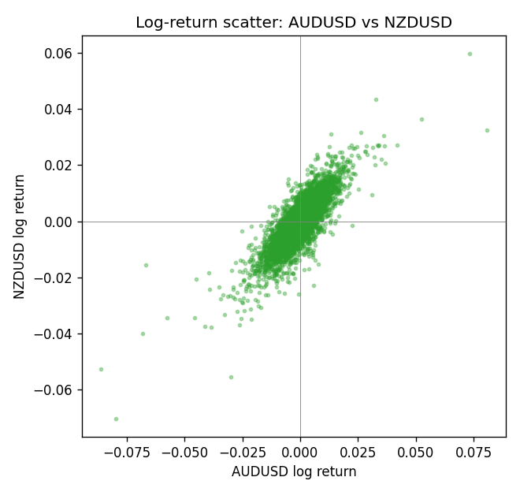

Data report
Every panel row for this pair slice is stored in the sibling Excel workbook named AUDUSD-NZDUSD_Shrinkage_D1.xlsx. Full-panel covariance and correlation matrices are saved once under outputs/ as CSV files. Embedding all rows as a Word table is impractical at this length; the Word file holds the column list, column summaries, and the first and last 15 matched rows.
Columns: time, AUDUSD_open, AUDUSD_high, AUDUSD_low, AUDUSD_close, AUDUSD_tick_volume, AUDUSD_spread, AUDUSD_real_volume, AUDUSD_log_return, NZDUSD_open, NZDUSD_high, NZDUSD_low, NZDUSD_close, NZDUSD_tick_volume, NZDUSD_spread, NZDUSD_real_volume, NZDUSD_log_return
Column summaries (panel rows)
column | count | mean | std | min | 25% | 50% | 75% | max
AUDUSD_open | 7127 | 0.75283275 | 0.13531386 | 0.4785 | 0.66158 | 0.7319 | 0.812805 | 1.10284
AUDUSD_high | 7127 | 0.75689359 | 0.13587198 | 0.4878 | 0.66567 | 0.73555 | 0.8193 | 1.10795
AUDUSD_low | 7127 | 0.74877471 | 0.1346251 | 0.4775 | 0.65837 | 0.72811 | 0.80713 | 1.0975
AUDUSD_close | 7127 | 0.75288849 | 0.13529323 | 0.4786 | 0.661725 | 0.7321 | 0.812865 | 1.10169
AUDUSD_tick_volume | 7127 | 78106.737 | 138648.75 | 109 | 5647 | 44017 | 71744.5 | 1234623
AUDUSD_spread | 7127 | 30.658622 | 16.888951 | 0 | 13 | 30 | 50 | 50
AUDUSD_real_volume | 7127 | 5.2965195e+09 | 1.2602867e+11 | 0 | 0 | 0 | 0 | 3.811512e+12
AUDUSD_log_return | 7127 | 3.23e-05 | 0.0075548 | -0.08602525 | -0.00385041 | 0.00029027 | 0.00415332 | 0.0806166
NZDUSD_open | 7127 | 0.65707489 | 0.10792246 | 0.3913 | 0.59224 | 0.66889 | 0.725215 | 0.88218
NZDUSD_high | 7127 | 0.66100044 | 0.10841069 | 0.3961 | 0.595625 | 0.6726 | 0.72964 | 0.88421
NZDUSD_low | 7127 | 0.65338952 | 0.10751648 | 0.3897 | 0.588615 | 0.6651 | 0.721335 | 0.87988
NZDUSD_close | 7127 | 0.65715675 | 0.10791625 | 0.3907 | 0.5923 | 0.66906 | 0.725335 | 0.8822
NZDUSD_tick_volume | 7127 | 69244.396 | 123501.01 | 17 | 5842 | 34224 | 58735 | 1127682
NZDUSD_spread | 7127 | 30.023572 | 25.540824 | 0 | 9 | 17 | 40 | 80
NZDUSD_real_volume | 7127 | 1.6834718e+10 | 8.5315436e+10 | 0 | 0 | 0 | 0 | 2.705649e+12
NZDUSD_log_return | 7127 | 2.447e-05 | 0.00764665 | -0.07027433 | -0.00423198 | 0.00024001 | 0.00459119 | 0.05966839
First 15 panel rows (selected columns)
time | AUDUSD_close | NZDUSD_close | AUDUSD_log_return | NZDUSD_log_return
1999-01-06 | 0.6289 | 0.5383 | 0.011836351 | 0.0020455609
1999-01-07 | 0.6345 | 0.5417 | 0.0088650256 | 0.0062963171
1999-01-08 | 0.6347 | 0.5414 | 0.00031515916 | -0.00055396548
1999-01-11 | 0.6393 | 0.547 | 0.0072213815 | 0.010290425
1999-01-12 | 0.6362 | 0.5441 | -0.0048608485 | -0.0053157489
1999-01-13 | 0.6312 | 0.5387 | -0.0078902098 | -0.0099742238
1999-01-14 | 0.6295 | 0.5386 | -0.002696916 | -0.00018564931
1999-01-15 | 0.634 | 0.5382 | 0.007123101 | -0.00074294208
1999-01-18 | 0.6346 | 0.5372 | 0.00094592471 | -0.0018597736
1999-01-19 | 0.6392 | 0.5382 | 0.0072225153 | 0.0018597736
1999-01-20 | 0.64 | 0.5404 | 0.0012507819 | 0.0040793678
1999-01-21 | 0.6405 | 0.5426 | 0.00078094498 | 0.0040627941
1999-01-22 | 0.6327 | 0.5361 | -0.012252745 | -0.012051689
1999-01-25 | 0.6302 | 0.5342 | -0.0039591468 | -0.0035504102
1999-01-26 | 0.6305 | 0.5381 | 0.00047592608 | 0.0072741158
Last 15 panel rows (selected columns)
time | AUDUSD_close | NZDUSD_close | AUDUSD_log_return | NZDUSD_log_return
2026-10-13 | 0.69821 | 0.56127 | 0.0035007712 | 0.0047326165
2026-10-14 | 0.69715 | 0.55918 | -0.0015193215 | -0.0037306483
2026-10-15 | 0.69191 | 0.56185 | -0.0075447063 | 0.0047634855
2026-10-16 | 0.69426 | 0.56509 | 0.0033906408 | 0.0057501001
2026-10-19 | 0.6978 | 0.56616 | 0.0050859986 | 0.0018917133
2026-10-20 | 0.70022 | 0.56827 | 0.0034620426 | 0.0037199341
2026-10-21 | 0.70275 | 0.57003 | 0.0036066384 | 0.0030923331
2026-10-22 | 0.70186 | 0.56815 | -0.0012672558 | -0.0033035227
2026-10-23 | 0.70353 | 0.56991 | 0.0023765656 | 0.0030929853
2026-10-26 | 0.70128 | 0.56826 | -0.0032032829 | -0.0028993932
2026-10-27 | 0.70245 | 0.56811 | 0.0016669876 | -0.00026399852
2026-10-28 | 0.70533 | 0.56261 | 0.0040915541 | -0.0097283914
2026-10-29 | 0.70245 | 0.56296 | -0.0040915541 | 0.00062190714
2026-10-30 | 0.70316 | 0.56307 | 0.0010102376 | 0.00019537668
2026-11-02 | 0.69971 | 0.56161 | -0.0049184984 | -0.0025962955

